# What I want you to design…. Check the index page and other pages and read the description below. No CSS only HTML. Make Your Luck Best

## Home Page

Having this heading and images on the top followed by a simple paragraph… Note the background and text color of the page. Please choose the same.

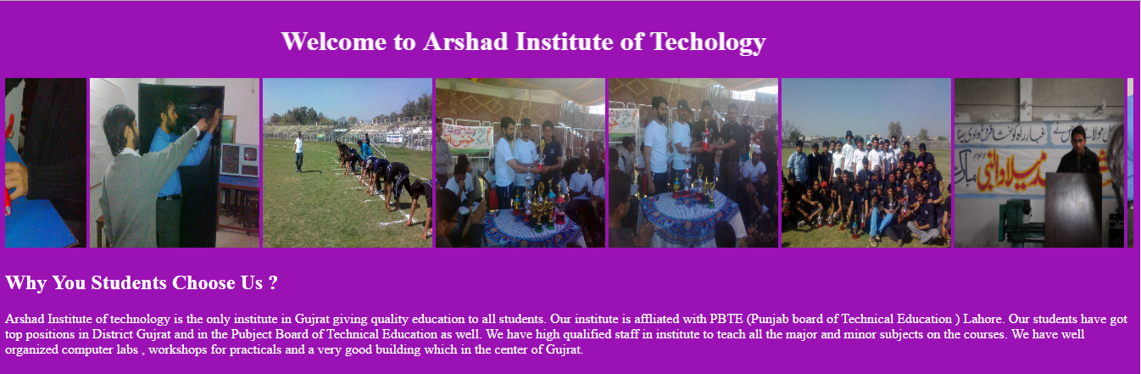

The heading on the top should move from right to left and pictures should move from left to right. The speed of heading should be faster than images.

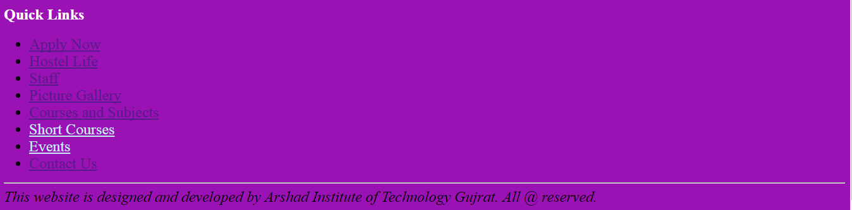

After that you have to add some links as above… Note the color of every link and choose the same. There should be a copyright notice after a line. It should be same as in the picture.

## Apply Now Page

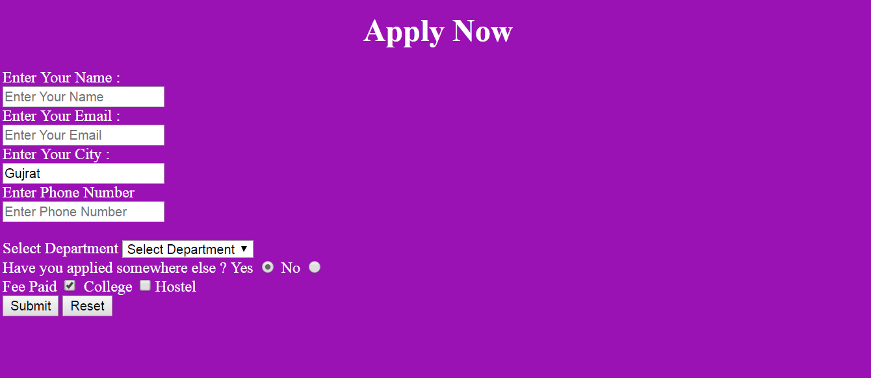

See the above Apply Now Page. It should be same as above. Note : form should not be submitted without name , email , phone number. Name and email should have placeholders but City should have a predefined value as above “gujrat” is written.

## Music Page

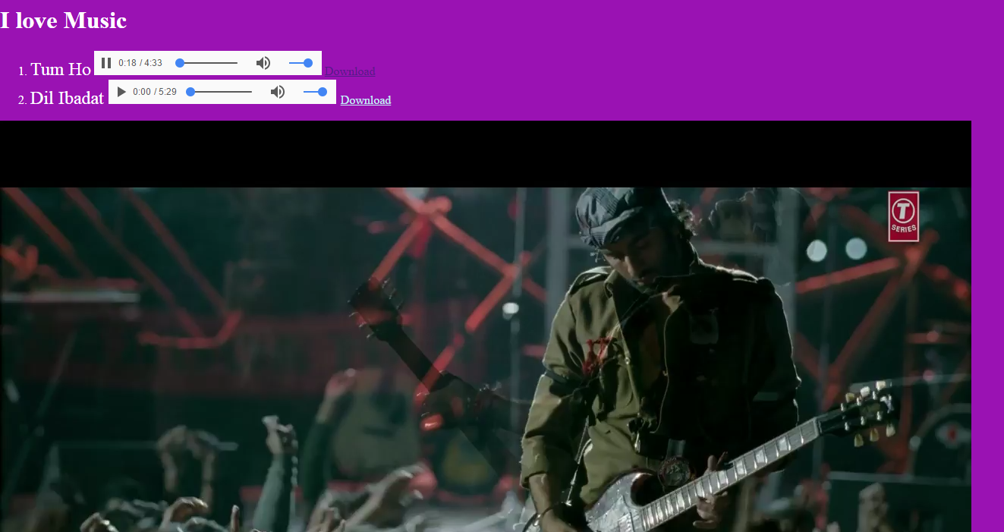

There should be 2 audio and 1 video file. The 1st file should be played automatically when someone visits the page. There should be download button to click and download facility.

Vidoe song should be repeted over and over again once it played.

## PDF file opening page.



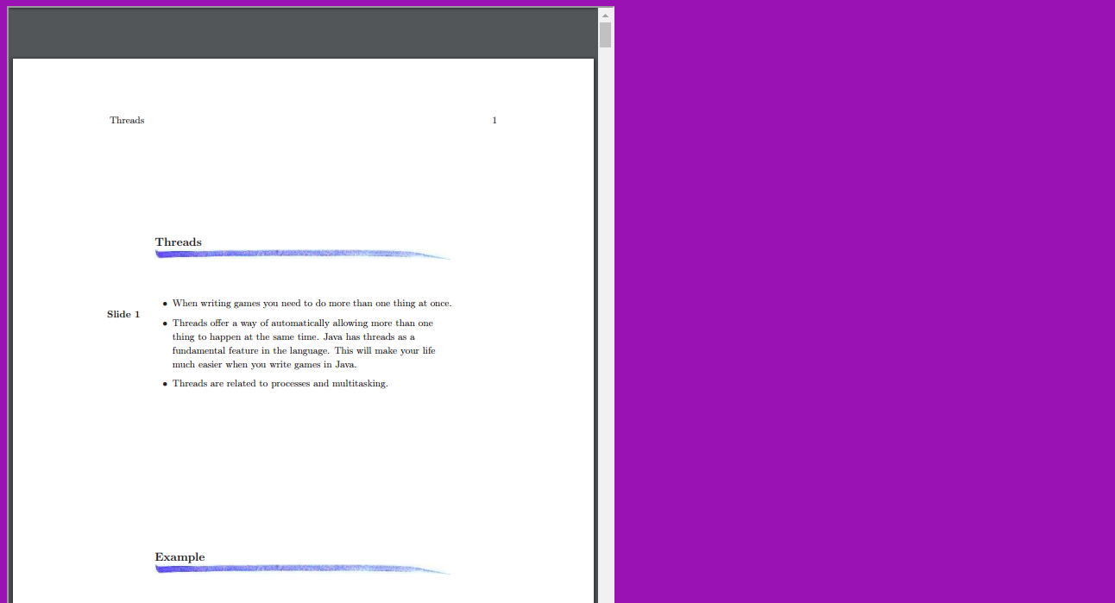

There should be a page which will be linked to another page. Page should open a pdf file without being downloaded to the computer.

## Picture Gallery Page

## 

A page should display some pictures with same height and width.

## Course Page

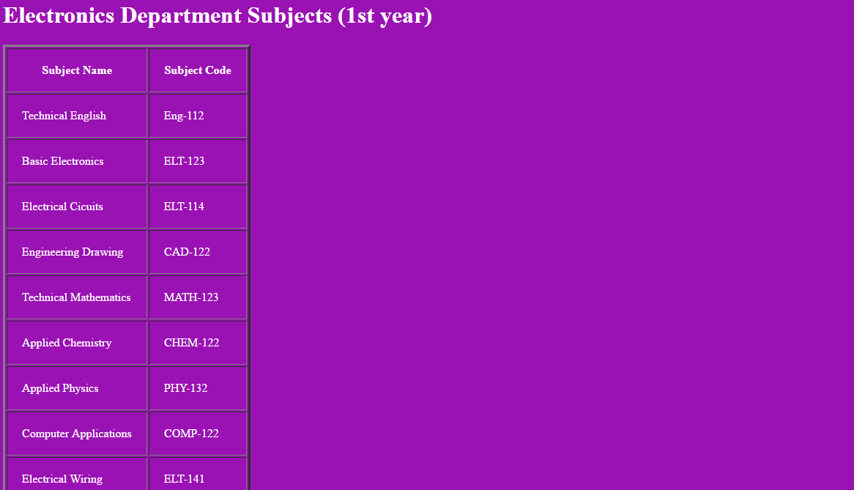

Make a course page same as above to display subjects codes in a table.

## Contact Us Page.

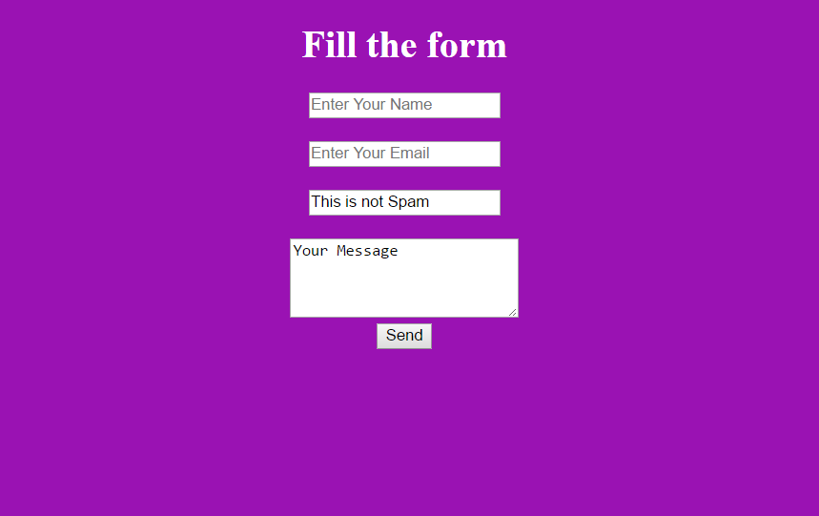

See the above page. There should be name , email and message fields. Form should not be submitted without entering name and email. There should be a field “ this is not spam” which could not be editable.